FOR IMMEDIATE RELEASE

CONTACT:
Katie Haemmerle, Stanford Live
khaemmer@stanford.edu
PHOTOS: http://live.stanford.edu/press

Stanford Live Reimagines 2020 Fall Season
for the Virtual Landscape with Short Film Series
First film to feature the St. Lawrence String Quartet on September 27
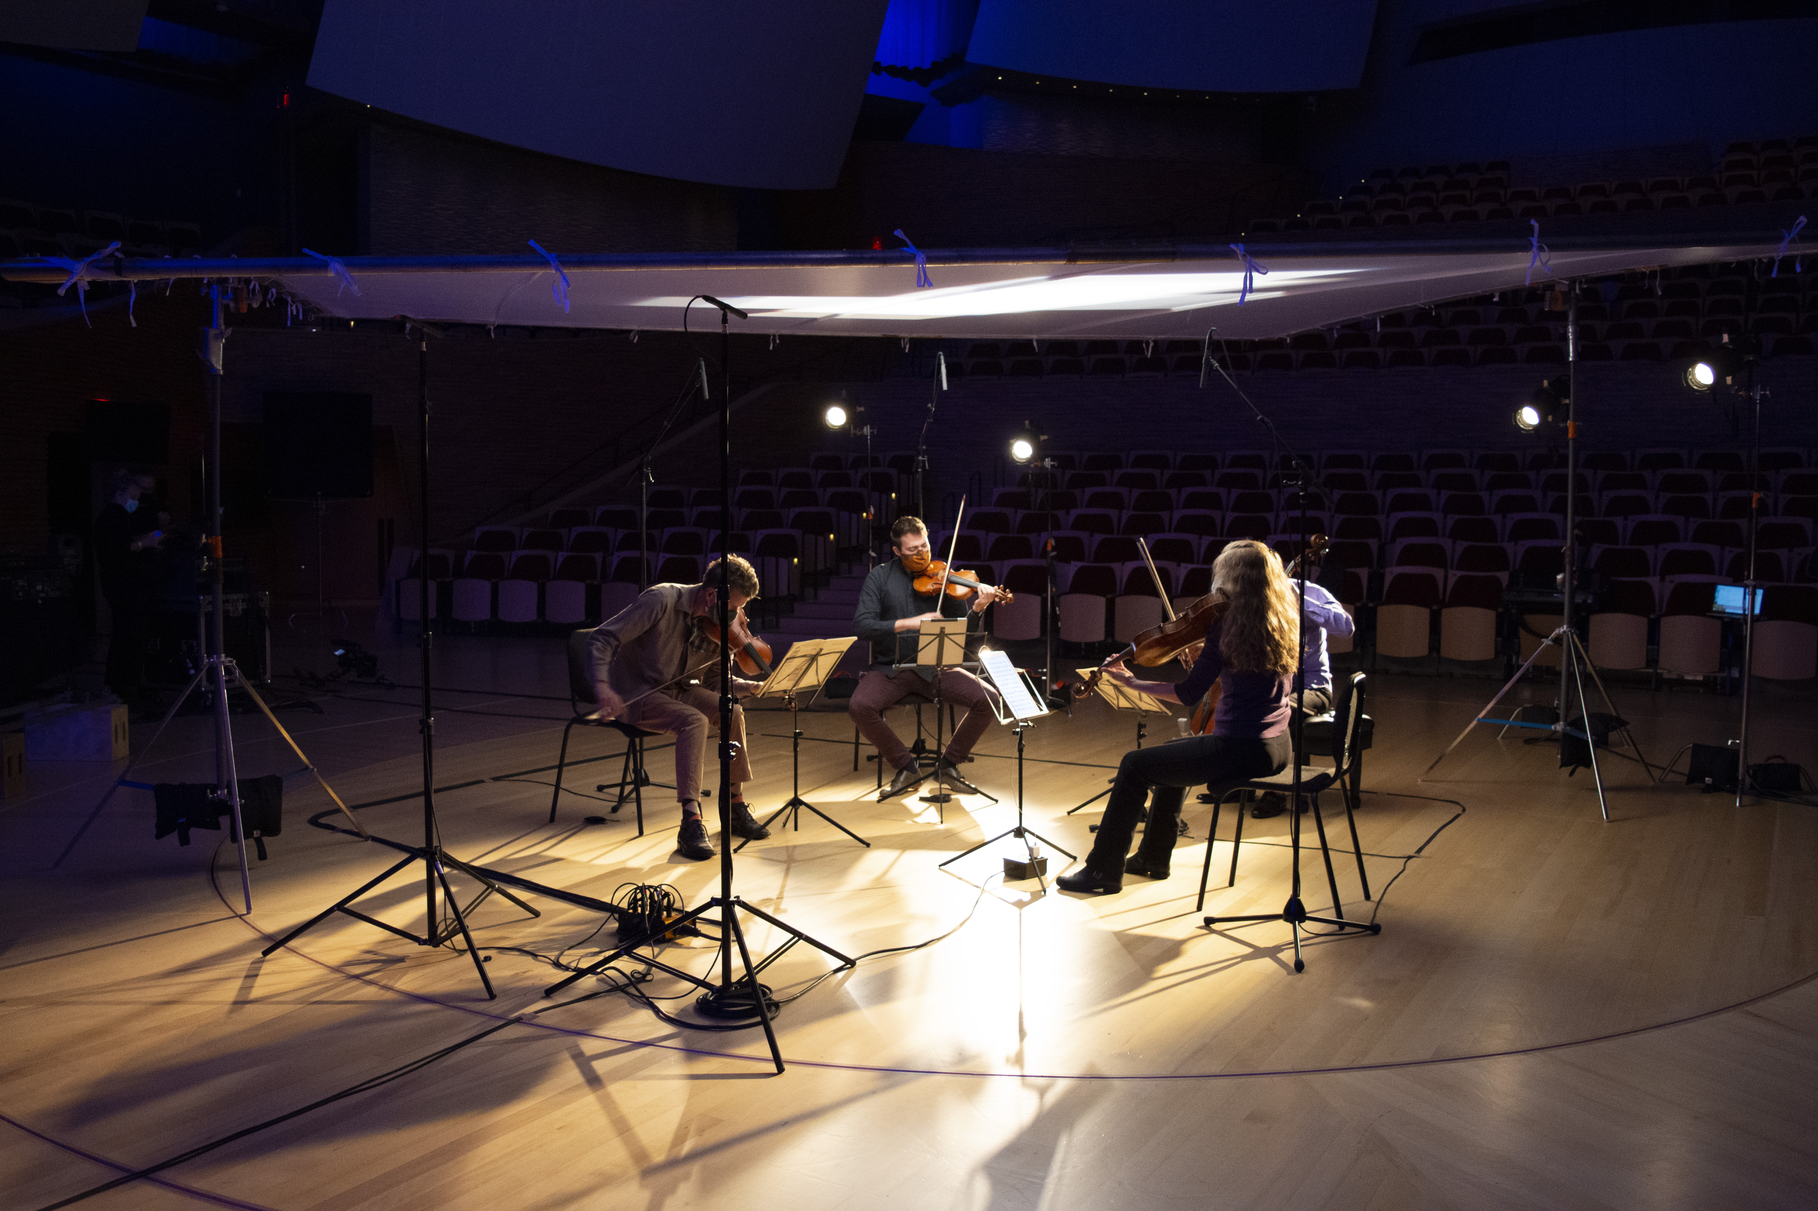

Stanford, CA, September 16, 2020—Despite the ongoing restrictions on in-person performances, it remains Stanford Live’s core mission to highlight the work of critical and talented artists from across all genres, this time in a reinvented virtual space. Artists will return to the stage at Bing Concert Hall for Stanford Live’s transformed fall season which includes a series of short films shot at the Bing.

Stanford’s ensemble-in-residence the St. Lawrence String Quartet will kick off the film series on Sep. 27 in a collaboration with Stanford Live, Stanford Associate Professor of Documentary Film and Video Jamie Meltzer, Stanford student editors, cinematographer Frazer Bradshaw, and renowned digital arts producer Elena Park.

“We’ve assembled an incredible group of artists and filmmakers to bring the magic of the Bing stage into living rooms throughout the Bay Area,” said Chris Lorway, Executive Director of Stanford Live. “While you can never replace the experience of live performance, we hope that seeing some of your favorite artists captured in film in our venue will bring you comfort and hope as we await our collective return to the theater.”

In their first appearance together since before the pandemic, the St. Lawrence String Quartet will play—in a masked and socially distanced performance—the entirety of Haydn’s String Quartet Op. 76 No. 5.

The film will be more than a virtual concert, though. Through interviews with members of the quartet, behind the scenes footage, and a peek into the personal lives of the musicians, the film tells the story of how the quartet has had to adapt its creative process amid months of COVID-19 restrictions that have resulted in their longest hiatus in the quartet’s 30-year history.

“We’re hoping to make these challenges transparent in the video itself,” Associate Professor Jamie Meltzer said. “It won’t pretend to be a ‘perfect’ performance, but rather it will show how the quartet faces these challenges and is able to create music that transcends the moment.”

Alongside Meltzer, Stanford documentary film students will be involved in the film’s editing process. In addition to the short film, a performance of Debussy’s String Quartet (II. Assez vif et bien rythmé and III. Andantino, doucement expressif) was captured by the Facebook Oculus team to be shared in 180 in the coming weeks.

More on the filming of the St. Lawrence String Quartet can be read here.

Additional Short Films and other Virtual Content
Other artists lined up for Stanford Live’s short film series includes pianist Garrick Ohlsson, musician Vân Ánh (Vanessa) Võ, and the Kronos Quartet, with more artists to be announced in the coming weeks. In addition, Stanford Live will screen performances recorded by audience favorites including the Takács Quartet, Manual Cinema, cellist Abel Selaocoe, and others.

An at-home version of Forced Entertainment’s Complete Works: Table Top Shakespeare will launch the week of Sep. 17 and will continue for 9 weeks, with four new plays added to the site each week. Each performance will feature one of six actors creating an hour-long narrative version of these popular plays from their kitchen tables using common household objects to bring the characters to life.

In Artists-in-Presidents: Fireside Chats for 2020, a new project curated by artist Constance Hockaday and co-produced by Stanford Live and UCLA’s Center for the Art of Performance (CAP UCLA), fifty artists will be paired with notable speechwriters to find their presidential voice. These national addresses kick off the week of Sep. 14. For more information, visit Artist-in-Presidents project page which includes the full list of participating artists.

Ticketed Events, Free Podcasts and Lectures, and More
Stanford Live will also host a few ticketed events this fall, including comedian Colin Quinn in a virtual book tour stop and innovative theater-makers 600 Highwaymen. Free Stanford Live podcasts, lectures, and more will be announced later this fall.

Lorway revealed these and other details about the new direction for the fall season in a webinar recorded on Sep. 3. For the latest additions to the Stanford Live digital fall season, visit live.stanford.edu/fall2020.

Access for Stanford Students and Stanford Live Members
Access to the short film series and select screenings will be free for all current degree-seeking Stanford students and Stanford Live members at the $100 Patron level or above. Join as a member today to receive 12 months of exciting member benefits such as free access to exclusive digital content, preferred presale opportunities, and invitations to special events. Visit our support page to learn more about member levels and benefits.

About Stanford Live
Stanford Live presents a wide range of fine performances from around the world, fostering a vibrant learning community and providing distinctive experiences through the performing arts. From its home at Bing Concert Hall, Stanford Live functions simultaneously as a public square, a sanctuary and a lab, drawing from all Stanford University has to offer to connect performance to the most significant issues, ideas and discoveries of our time.

We take a moment to recognize that Stanford sits on the territory of Huichin, the ancestral and unceded land of the Muwekma Ohlone Tribe, who are the successors of the historic and sovereign Verona Band of Alameda County. This land was and continues to be of great importance to the Ohlone people. We recognize that every member of the community has benefited—and continues to benefit—from the use and occupation of this land. Consistent with our values of community and diversity, we have a responsibility to acknowledge and make visible the University’s relationship to Native people.

The Stanford Live season is sponsored by Stanford Health Care
https://live.stanford.edu/
https://www.facebook.com/stanfordlive
https://www.instagram.com/stanfordlive/

# # #

