Stanford Live partners with Goldenvoice and the San Francisco Symphony
The partnership at Frost Amphitheater includes rock, pop, and classical concerts, as well as spoken word performances in the inaugural season of this newly renovated venue in the university’s arts district.
Stanford University is excited to announce two musical partnerships. Stanford Live, the university’s primary performing arts organization, is co-presenting a series of concerts in Frost Amphitheater with Goldenvoice, creators of Coachella Valley Music & Arts Festival and local promoter of over 600 Bay Area concerts annually.
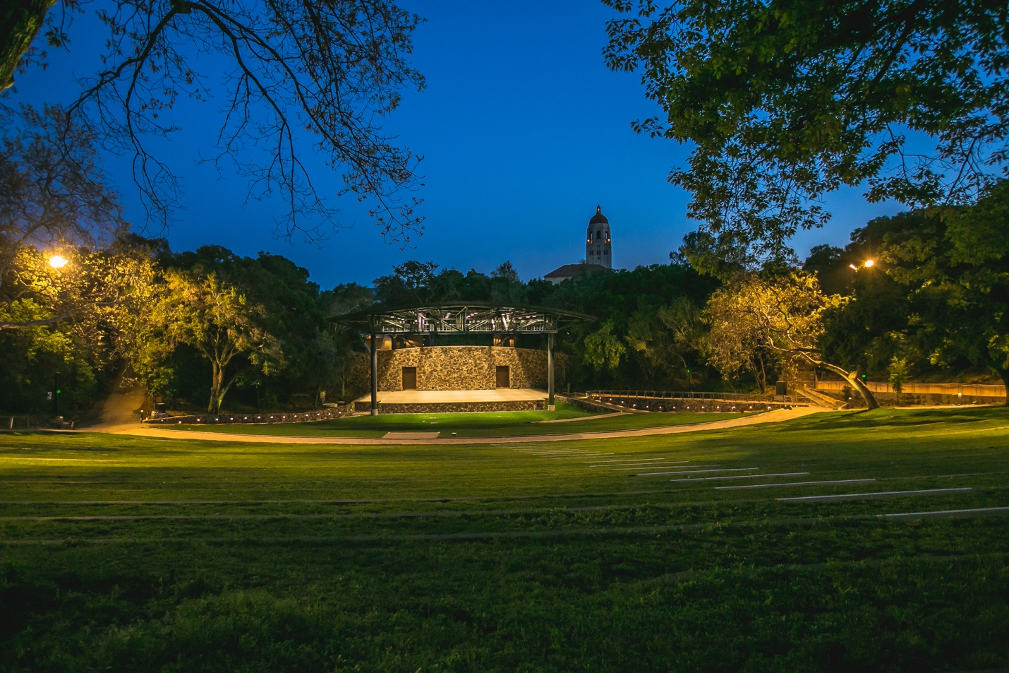
Frost Amphitheater reopened this spring after an extensive renovation project that includes the addition of a state-of-the-art stage and other front- and back-of-house amenities that improve conditions for audience members and performers.
Stanford Live is also co-presenting a summer series in Frost with the San Francisco Symphony (SFS), widely considered to be among the most artistically adventurous and innovative arts institutions in the U.S. The Stanford Live-SFS series will take place in July 2019 and will be the first classical music concerts in the newly renovated amphitheater.
“We have found two wonderful collaborators in Goldenvoice and the San Francisco Symphony,” said Chris Lorway, executive director of Stanford Live/Bing Concert Hall. “Both are committed to bringing the highest level of musical experiences to audiences which aligns beautifully with our mandate at Stanford Live. These annual concerts and events will also provide Stanford an opportunity to engage further with the local community as we collectively build Frost into the preeminent outdoor music venue on the peninsula.”
Frost Amphitheater, the legendary 82-year-old venue, is located at 351 Lasuen St. in the university’s arts district that includes Bing Concert Hall, the Cantor Arts Center, the Anderson Collection at Stanford University and the McMurtry Building for the Department of Art and Art History. The extensive renovation project includes the addition of a state-of-the-art stage and other front- and back-of-house amenities that improve conditions for audience members and performers. A new era of popular music at Frost Amphitheater kicks off on July 17th with ODESZA. Tickets are on sale starting Friday, June 7th at 10 a.m. PT.
- Wednesday, July 17th – ODESZA (Goldenvoice Concert Series Grand Opening)
The Stanford Live-Goldenvoice 2019 concert series will begin in July and continue through October. Several more shows will be announced in the coming months. Tickets for the following shows are on sale now:
- Saturday, August 17th – Joe Russo’s Almost Dead
- Saturday, August 24th – Lionel Richie
- Sunday, September 1st – The National with Alvvays
“Goldenvoice is honored to be tasked with programing contemporary music at Frost Amphitheater,” said Rick Mueller, North American president of AEG Presents, Goldenvoice’s parent company. “From Miles Davis to Ella Fitzgerald, and Carlos Santana to the Grateful Dead, Frost has hosted the best artists of its time, and the venue’s history serves as a musical blueprint that is hard to match anywhere in the world. We look forward to continuing this great tradition and bringing the best artists of today to Frost with our partners at Stanford Live.”
The Stanford Live-SFS concert series will take place each summer. Tickets for the following performances are on sale now:
- Wednesday, July 10, 2019 at 7:30 PM – Gemma New leads the SFS in an all-Tchaikovsky concert featuring the composer’s Symphony No. 5 and Violin Concerto, performed by American violinist Gil Shaham.
- Saturday, July 13, 2019 at 7:30 PM – New Zealand-born conductor Gemma New leads the SFS in a concert featuring Beethoven’s Symphony No. 9.
- Sunday, July 14, 2019 at 4:00 PM – Same program as July 13.
“The San Francisco Symphony is thrilled to strengthen our relationship with Stanford University as we begin our first season in the beautiful and beloved Frost Amphitheater,” said symphony president and Stanford alumna Sakurako Fisher. “Our orchestra has a great history at Frost and this series serves as a wonderful opportunity for the broader Bay Area community to, once again, enjoy our music under the sun and stars in this historic tree-lined bowl. We also hope our unique partnership will allow an even greater exchange of musical ideas through new creative and academic partnerships with Stanford as it continues to carry and lead in the balancing of the arts with the sciences.”

Tickets for Stanford Live-Goldenvoice performances
For all performances co-presented by Stanford Live and Goldenvoice, tickets will be available for purchase through the AXS ticketing system. Presale access will be available to select Stanford Live members. For more information, visit www.frostamphitheater.com & Goldenvoice.com

Tickets for Stanford Live-San Francisco Symphony performances
Tickets for the 2019 Stanford Live-SFS performances will be available on presale to Stanford Live members and SFS donors and subscribers starting Feb. 19 at 10 a.m. and to the general public starting Feb. 26 at 10 a.m. via www.sfsymphony.org/frost, (415) 864-6000 and the Davies Symphony Hall Box Office, located on Grove Street between Franklin and Van Ness, San Francisco.

About Stanford Live
Stanford Live presents a wide range of the finest performances from around the world fostering a vibrant learning community and providing distinctive experiences through the performing arts. With its home at Bing Concert Hall, Stanford Live is simultaneously a public square, a sanctuary and a lab, drawing on the breadth and depth of Stanford University to connect performance to the significant issues, ideas and discoveries of our time.

About Goldenvoice
Goldenvoice, creators of Coachella Valley Music & Arts Festival and Stagecoach: California’s Country Music Festival, also produces Arroyo Seco Weekend, Camp Flog Gnaw Carnival and operates Los Angeles and San Francisco Bay Area music venues including El Rey Theatre, The Fonda Theatre, The Novo, Shrine Auditorium, Mountain Winery, The Regency Ballroom and The Warfield. Beginning as an independent punk rock promoter in 1981, Goldenvoice now promotes over 1,800 shows a year in California, Nevada, Alaska, Arizona, Hawaii and Canada.

About San Francisco Symphony
Under the artistic direction of Michael Tilson Thomas since 1995, the orchestra is a leading presence among American orchestras at home and around the world, celebrated for its artistic excellence, creative performance concepts, active touring, award-winning recordings and standard-setting education programs. SFS presents more than 220 concerts and presentations annually for an audience of nearly 450,000 in its home of Davies Symphony Hall and through its active national and international touring.

