FOR IMMEDIATE RELEASE
CONTACT:
Katie Haemmerle, Stanford Live
khaemmer@stanford.edu
PHOTOS: http://live.stanford.edu/press

The Ritual of Breath Is the Rite to Resist weaves music, song, dance, and visual media in a call for action and communal healing

Multimedia opera responding to the murder of Eric Garner features composer Jonathan Berger, artist Enrico Riley, and soprano Neema Bickersteth
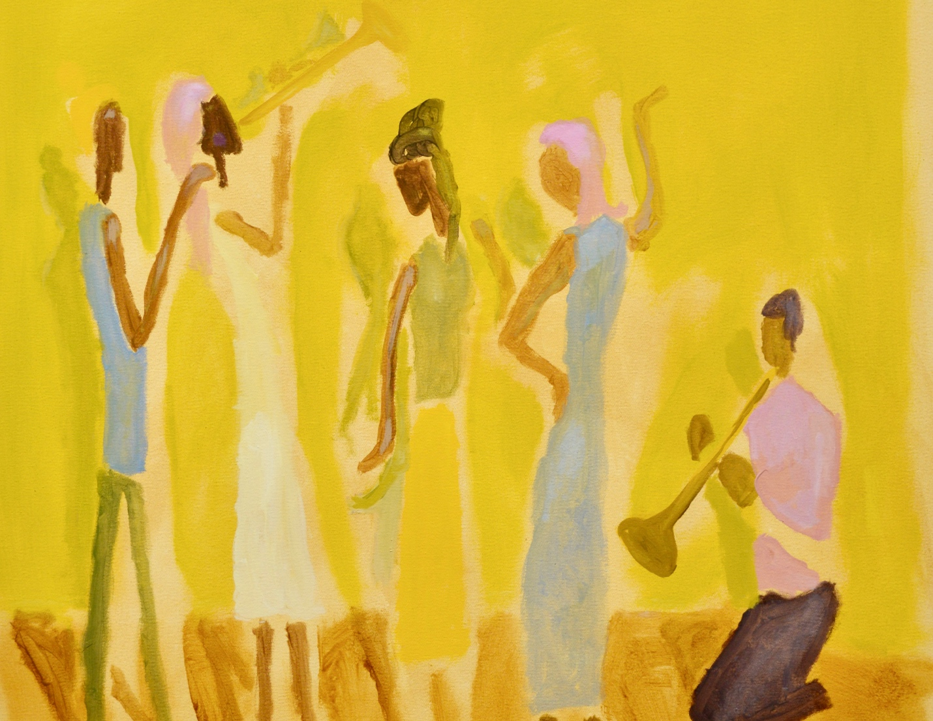
The Ritual of Breath Is the Rite to Resist is a multimedia contemporary opera of music, dance, text projections, and artwork depicting Black life. Artwork by Enrico Riley

Stanford, CA, September 6, 2022—Stanford Live will present the groundbreaking contemporary opera The Ritual of Breath Is the Rite to Resist (Oct 14 & 15), a meditative multimedia work responding to the murder of Eric Garner. A co-commission with The Hopkins Center for the Arts at Dartmouth, the opera in seven movements interweaves music, text, visual imagery, and movement in a creative act of resistance, healing, and communal breath.

Reverberating against the ongoing theft of Black breath by the police, the immersive multimedia project was born from a collaboration between Dartmouth professor of studio art Enrico Riley and composer and Stanford professor of music Jonathan Berger. The two then engaged Vievee Francis, a poet, to craft the powerful libretto. As the project evolved, other artist-activists joined the team including pioneering theater director Niegel Smith, conductor Kamna Gupta, and soprano Neema Bickersteth.

"When my Dartmouth colleague Mary Lou Aleskie reached out to me about this project nearly five years ago, we knew we had to be involved,” says Chris Lorway, Stanford Live’s Executive Director. “It has provided an important opportunity for both of our campuses to work with an incredible roster of artists whose healing work has only become more urgent over the past couple of years.”

With Berger’s score and Riley’s paintings and drawings depicting Black life, the opera follows the protagonist Erica as she grieves the loss of her father to police violence and encourages her community to engage in rituals of healing. By revealing the ways in which police violence impacts Black and brown communities, The Ritual of Breath Is the Rite to Resist builds a shared experience for the audience, evoking empathy while also urging the audience to engage in activism beyond what happens on stage.

Leading up to the performances, ticket buyers and community members will participate in digital and in-person rituals with prompts for meditation and personal reflection. Designed by activist Dr. Shamell Bell and director Niegel Smith, the rituals are rooted in art practices such as music, spoken word, and visual art that invite participants to share in communal acts of healing. The rituals also include behind the scenes videos of Ms. Gwen Carr––Eric Garner’s mother––and members of the creative team whose perspectives will ground the performance and contextualize the importance of healing practices for people affected by social injustices.

“Ritual of Breath will be an undertaking that involves spiritual practice and community engagement,” says Dr. Kimberly Thomas McNair, Stanford Lecturer in African and African American Studies and creative producer for engagement for the Ritual of Breath performances at Stanford Live. “Though this stage production focuses on incidents that are specific to New York, police brutality is also a longstanding issue in the Bay Area.”

Prior to the Ritual of Breath performances, Stanford Live will host a speaker event featuring Ms. Carr who will share her perspective with various student groups and local organizations.

“Historically, Bay Area community organizations such as the Black Panther Party initiated community programs and citizen patrols to counter police violence toward the Black community,” says McNair, who is engaging communities and organizations in the Bay Area that are working to address police violence. “And the broader Movement for Black Lives has built a network of community organizations that serve as a support system for affected families, with some of the most influential organizations originating here in the Bay Area.”

The Ritual of Breath Is the Rite to Resist is creatively produced by Kim Whitener/KiWi Productions, with scenic & projection by Peter Nigrini, lights by Reza Behjat, sound by Sadah Espii Proctor, and costumes by Gabriel Berry. The complete list of creators, performers, and collaborators for The Ritual of Breath Is the Rite to Resist is available on Stanford Live’s website.

Credits
Generously supported by the Stanford Live Commissions and Programming Fund.

Commissioned, developed, and produced by The Hopkins Center for the Arts at Dartmouth and co-commissioned by Stanford Live.

Tickets and More Information
Tickets are on sale now at live.stanford.edu.

The Ritual of Breath Is the Rite to Resist
An offering. An opera in seven movements. A call for justice.
Friday, Oct 14, 7:30 pm
Saturday, Oct 15, 2:30 pm
Bing Concert Hall
Tickets start at $32

About Stanford Live
Stanford Live presents a wide range of fine performances from around the world, fostering a vibrant learning community and providing distinctive experiences through the performing arts. From its home at Bing Concert Hall and Frost Amphitheater, Stanford Live functions simultaneously as a public square, a sanctuary and a lab, drawing from all Stanford University has to offer to connect performance to the most significant issues, ideas and discoveries of our time.

We take a moment to recognize that Stanford sits on the territory of Huichin, the ancestral and unceded land of the Muwekma Ohlone Tribe, who are the successors of the historic and sovereign Verona Band of Alameda County. This land was and continues to be of great importance to the Ohlone people. We recognize that every member of the community has benefited—and continues to benefit—from the use and occupation of this land. Consistent with our values of community and diversity, we have a responsibility to acknowledge and make visible the University’s relationship to Native people.

The Stanford Live season is sponsored by Stanford Medicine

https://live.stanford.edu/
https://www.facebook.com/stanfordlive
https://www.instagram.com/stanfordlive/

# # #

