FOR IMMEDIATE RELEASE

CONTACT:
Katie Haemmerle, Stanford Live
khaemmer@stanford.edu
PHOTOS: http://live.stanford.edu/press

The Season That Never Was Returns to Stanford Live
2021–22 season examines themes of reconciliation and forgiveness, highlights Indigenous and South African voices, and features major U.S. dance premieres

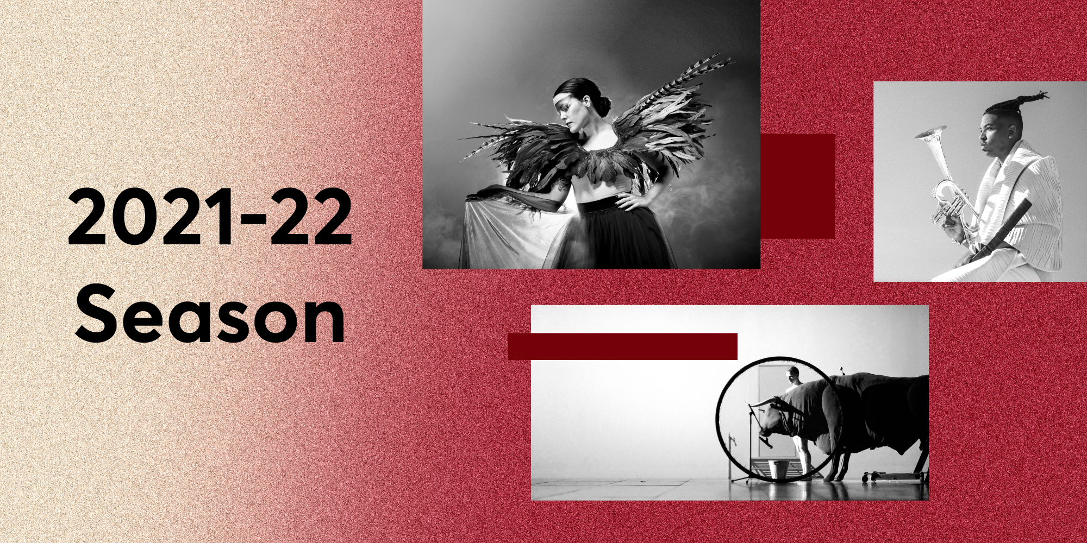

Stanford, CA, July 20, 2021—Stanford Live’s upcoming 2021–22 season will look familiar, as many of the artists originally scheduled last season will at last take the stage at Stanford Live. The narrative focus of the previous season carries over, with themes of reconciliation and forgiveness shaping the arc of performances. From artists whose work shares the histories and culture of Indigenous people across the globe to performances that highlight the important role reconciliation plays in addressing histories and building inclusive communities, Stanford Live’s 2021–22 season seeks to empower artists and the important visions their work embodies.

"It’s very surreal to be announcing such a similar program more than one year later,” says Chris Lorway, Executive Director of Stanford Live. “We are thrilled to honor the commitments we made to so many artists over the past two years and look forward to hosting them on campus.”
The 2020–21 line-up features jazz performances by Christian Scott aTunde Adjuah (Oct 9) and Nduduzo Makhathini (Apr 28) and orchestra performances from the Russian National Orchestra led by Kirill Karabits (Feb 20), New Century Chamber Orchestra with music director Daniel Hope (Jan 22), and Orpheus Chamber Orchestra with Branford Marsalis (Jan 12). Hip-hop artist Frank Waln and singer-song writer Raye Zaragoza (Feb 3) share the stage in the Bing Studio and Patti LuPone (Jan 14) brings a solo show to the concert hall. Theater performances include And So We Walked: An Artist’s Journey Along the Trail of Tears (May 20, 21 & 22), Anthony Hudson/Carla Rossi’s Queer Horror’s Gravest Hits and Carla Rossi Does Drag (Nov 5 & 6), Cliff Cardinal’s Huff (Jan 27 & 28), and a return visit from Inua Ellams with An Evening with an Immigrant (Jan 29 & 30).

Major Dance Premieres
Three major dance works co-commissioned by Stanford Live will have their U.S. premiere during the 2021–21 season.

Requiem: Fire in the Air of the Earth (Dec 4) premieres at Stanford Live following a week-long residency. The new work by choreographer and MacArthur Fellow Kyle Abraham and composer and EDM artist Jlin explores death, folklore, and reincarnation through a reimagining of Mozart’s Requiem in d minor. Ten dancers from Abraham’s dance company A.I.M join Jlin to transform Mozart’s music into an electronic opus of ritual, mourning, and birth.

Originally scheduled for the 2019–20 season and the first performance to be canceled in 2020 due to the COVID-19 pandemic, dance legend Yang Liping’s stunning reimagining of Stravinsky’s The Rite of Spring will premiere at Stanford Live in 2022. Her production of Rite of Spring (Jan 21 & 22) spins an abstract legend of the path of salvation embodied by the sacrificial peacock, creating a distinct universe where time, space, and life coexist in endless reincarnation.

Transverse Orientation (May 14 & 15) by groundbreaking Greek director, choreographer, and visual artist Dimitris Papaioannou will also make its U.S. premiere at Stanford Live. Co-commissioned by Stanford Live, Papaioannou’s latest work is an evening-length epic combining music and elaborate stage imagery in enigmatic but powerful ways.

“In 2018, I travelled to Montreal to see Dimitris' piece The Great Tamer,” says Lorway. “His visual landscape was both immaculate and raw and had me on the edge of my seat for the entire performance. I couldn't wait to see what was next.”

Additional dance productions include Memphis Jookin’: The Show featuring Lil Buck (Feb 28), an ode to Lil Buck’s hometown of Memphis that chronicles the emergence of the unique dance style known as Memphis jookin’, and FRAY from CandyBomber Productions (May 26 & 27), a fusion of hip-hop, ballet, and video game design.

Artist Residencies
Supporting artists remains paramount to Stanford Live’s mission, especially after more than a year of disruption and uncertainty in the performing arts due to COVID-19. Stanford Live continues to increase investment in commissions and co-productions and now is expanding its residency opportunities to give artists the time, space, and resources to develop new work at Stanford.

Two residencies will kick off the 2021–22 season, starting with a new work commissioned by Philharmonia Baroque Orchestra, Stanford Live, and the American Modern Opera Company. Matthew Aucoin’s The No One’s Rose will have its world premiere at Bing Concert Hall in August (Aug 25–29), the first performance with an audience in the hall since it closed in March 2020. This ambitious project has been six years in the making and features an all-star cast and creative team.

In early September, electro pop artist and Indigenous rights activist iskwē—whose influences span jazz, R&B, industrial pop rock, and trip-hop—will take over the Bing with her immersive new work acākosīk (Sep 29 and 30), transforming the entire building into a space to experience her visceral and multidisciplinary performance.

Additional commissioned works this season include a new song cycle on digital surveillance by Gabriel Kahane (May 11) and 32 Sounds (Feb 11), a new film/live performance by Academy Award-nominated filmmaker Sam Green.

Tickets and More Information
Member presale access begins on July 22. Tickets go on sale to the general public on August 24. In order to best prepare for potential changes in light of COVID-19, only tickets to shows scheduled from September through December will be available for purchase during the summer onsale. Visit live.stanford.edu for updates on sales to later performances.

To read about health and safety protocols, visit our FAQ.
Fall Schedule

Chamber

Sundays with the St. Lawrence with cellist Paul Wiancko
Sunday, Oct 10, 2021, 2:30 PM
Bing Concert Hall

Contemporary

The No One’s Rose
A world premiere by the American Modern Opera Company in partnership with Philharmonia Baroque Orchestra and Stanford Live
Wednesday & Thursday, Aug 25 & 26, 7:30 pm
Sunday, Aug 29, 2:30 pm
Bing Concert Hall
Tickets on sale now

iskwē
acākosīk
Wednesday & Thursday, Sep 29 & 30, 2021, 7:30 PM
Bing Concert Hall

Pink Martini Holiday Spectacular
Sunday, Dec 12, 2021, 4:00 PM
Bing Concert Hall

Dance

Requiem: Fire in the Air of the Earth
A new work by Kyle Abraham and Jlin featuring A.I.M
Saturday, Dec 4, 2021, 7:30 PM
Memorial Auditorium

Discussion/Performance

National Geographic Live
Greenwood: A Century of Resilience with Alicia Odewale
Wednesday, Nov 10, 2021, 7:30 PM
Bing Concert Hall

Selected Shorts
Sunday, Dec 5, 2021, 2:30 PM
Bing Concert Hall

Films with Live Music

A Thousand Thoughts
A Live Documentary by Sam Green and Kronos Quartet
Wednesday, Oct 6, 2021, 7:30 PM
Bing Concert Hall

Folk

Derek Gripper and Yacouba Sissoko
Friday, Oct 8, 2021, 7:00 & 9:00 PM
Bing Studio

Jazz

Christian Scott aTunde Adjuah: Ancestral Recall
Saturday, Oct 9, 2021, 7:00 PM & 9:00 PM
Bing Studio

Fandango at the Wall
Arturo O’Farrill and the Afro-Latin Jazz Orchestra with special guests Villalobos Brothers
Wednesday, Oct 13, 2021, 7:30 PM
Bing Concert Hall

Jaz Sawyer
We Insist! Freedom Now Suite
Featuring Jazzmeia Horn with special guest Tongo Eisen-Martin
Friday, Nov 12, 2021 7:00 PM
Bing Studio

Jaz Sawyer
The Message Forward
Featuring Kim Nalley with special guest Tongo Eisen-Martin
Saturday, Nov 13, 2021 7:00 PM
Bing Studio

Orchestral

Philharmonia Baroque Orchestra
Bach’s Christmas Oratorio
Friday, Dec 10, 2021, 7:30 PM
Bing Concert Hall

Recital

Gil Shaham, violin and Akira Eguchi, piano
Wednesday, Dec 8, 2021, 7:30 PM
Bing Concert Hall

Singer-Songwriter

William Prince
Thursday, Nov 11, 2021, 7:00 PM & 9:00 PM
Bing Studio

Tango

Quinteto Astor Piazzolla
Thursday, Nov 4, 2021, 7:30 PM
Bing Concert Hall

Theater

The War of the Worlds
Rhum and Clay Theatre Company, written with Isley Lynn
Thursday & Friday, Oct. 28 & 29, 2021, 7:30 PM
Bing Concert Hall

Anthony Hudson/Carla Rossi: Queer Horror Gravest Hits
Friday, Nov 5, 2021, 9:00 PM
Bing Studio

Anthony Hudson/Carla Rossi: Carla Rossi Does Drag
Saturday, Nov 6, 2021, 8:00 PM
Bing Studio

Vocal

Vienna Boys Choir
Monday, Nov 29, 2021, 7:00 PM
Bing Concert Hall

A Chanticleer Christmas
Thursday, Dec 16, 2021, 7:30 PM
Memorial Church

Health and Safety Guidelines
In light of COVID-19’s impacts around the world, there are many factors that may affect Stanford Live’s season. Some performances may need to move venues in order to work more safely—and some may be rescheduled or canceled entirely. Stanford Live promises to keep all patrons informed. Refunds and exchanges will be available for all canceled or rescheduled performances.

Stanford Live continues to work closely with health and university officials to ensure a safe experience for patrons. All events at Bing Concert Hall, Bing Studio, Frost Amphitheater, and other venues on the Stanford University campus adhere to guidelines issued by the Centers for Disease Control (CDC), Santa Clara County, the state of California, and Stanford University for increased health and safety procedures.

Capacity and Seating
Tickets for 2021–22 season shows scheduled in the fall will be sold at full capacity.

Public Health Practices
Across all Stanford Live indoor venues, masks are required for both unvaccinated and vaccinated patrons. Patrons should bring their own face coverings that cover their nose and mouth and wear them at all times. Masks with valves will not be allowed.

Patrons should stay home if they are experiencing a fever or any COVID-19 symptoms, have tested positive for COVID-19 within the past 14 days, or have had close contact with anyone who is confirmed or is suspected of having COVID-19.

About Stanford Live
Stanford Live presents a wide range of fine performances from around the world, fostering a vibrant learning community and providing distinctive experiences through the performing arts. From its home at Bing Concert Hall and Frost Amphitheater, Stanford Live functions simultaneously as a public square, a sanctuary and a lab, drawing from all Stanford University has to offer to connect performance to the most significant issues, ideas and discoveries of our time.

We take a moment to recognize that Stanford sits on the territory of Huichin, the ancestral and unceded land of the Muwekma Ohlone Tribe, who are the successors of the historic and sovereign Verona Band of Alameda County. This land was and continues to be of great importance to the Ohlone people. We recognize that every member of the community has benefited—and continues to benefit—from the use and occupation of this land. Consistent with our values of community and diversity, we have a responsibility to acknowledge and make visible the University’s relationship to Native people.

The Stanford Live season is sponsored by Stanford Medicine

https://live.stanford.edu/
https://www.facebook.com/stanfordlive
https://www.instagram.com/stanfordlive/

# # #

