FOR IMMEDIATE RELEASE
CONTACT:
Katie Haemmerle, Stanford Live
khaemmer@stanford.edu
PHOTOS: http://live.stanford.edu/press

Stanford Live to Host Two Performances of Dimitris Papaioannou’s Breathtakingly Beautiful Transverse Orientation
After Rescheduling the Original Spring Dates
The genre-bending Olivier Award-nominated production
fuses dance, visual art, and theater

“…an epic visual impact…”
—The New York Times
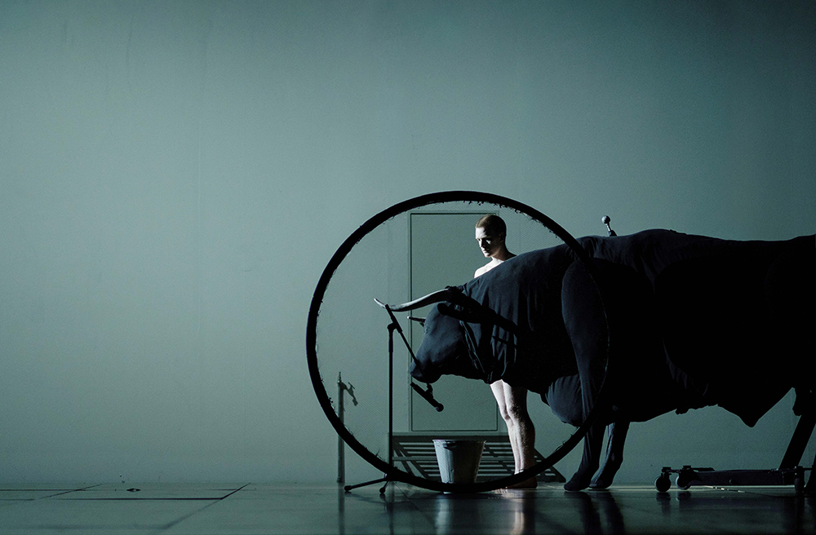
Two performances of Transverse Orientation by internationally recognized Greek choreographer
Dimitris Papaioannou will take place at Memorial Auditorium on December 9 and 10. Photo by Julian
Mommert

Stanford, CA, November 10, 2022—Transverse Orientation, the latest creation by groundbreaking Greek director, choreographer, and visual artist Dimitris Papaioannou, makes a stop at Stanford Live on December 9 and 10 following its North American premiere at Brooklyn Academy of Music on November 7 and a successful international run that included performances at Sadler’s Wells and La Biennale de Lyon. Originally set to host the North American premiere in May 2022, Stanford Live made the difficult decision to reschedule Transverse Orientation due global COVID-19-related visa and transportation challenges.

The New York Times described Transverse Orientation as a "beautiful sight to behold" and a performance balancing "a tension between grandeur and simplicity...[that] make[s] epic visual imprints.” Commissioned by an international consortium that includes Stanford Live, Papaioannou’s new production (which received an Olivier Award nomination for Best New Dance Production) is an epic evening-length work that combines sculptural bodies, life-like puppets and mythical creatures with contemporary movement that oscillates between the absurd, surrealism, and dreams. Taking inspiration from the natural behavior of moths to seek light and major themes from Greek mythology, Transverse Orientation follows the human compulsion to find meaning on its journey.

“I was first introduced to Dimitris in Montreal when I attended a performance of The Great Tamer at the recommendation of many of my international colleagues” says Chris Lorway, Stanford Live’s Executive Director. “I was immediately transported into his visual world and was transfixed for the entirety of the performance––I knew at that moment that I wanted to support the creation of his next piece. I’m so excited to share this stellar work with Bay Area audiences.”

In 2018, Papaioannou was the first choreographer to create a new evening length work for Tanztheater Wuppertal Pina Bausch since Bausch’s death in 2009. He also conceived and directed the opening and closing ceremonies for the 2004 Olympic Games in Athens. With a background rooted in painting and visual art, Papaioannou is a true master of visual spectacle and creations that blur theater, experimental choreography, and live performance. Transverse Orientation continues his talent for visual theater, packing powerful and suggestive images that capture the painterly quality of Papaioannou’s work with choreography that transforms the human body and objects through illusion. Beauty and absurdity sit side by side, challenging traditional notions of beauty with vivid scenes that offer as much poignance as levity and humor.

For the first time, Papaioannou put together an international cast, which includes eight dancers selected from more than five hundred who auditioned. The final group of dancers––described by The New York Times as “expert puppeteers of themselves”––worked closely with Papaioannou throughout the playful, intuitive creative process.

“My works evolve during rehearsal. They are not composed beforehand,” Papaioannou says. “I prepare material only in order to kick-start the process––and most of the time, I throw it out. I’ve resolved to not know what the outcome will be ahead of time, to trust in the process. In the end, if I’m lucky, the work reveals itself, and I try to understand it, to perfect it’s meaning, to help it become clearly what it is.”

Warning: This production contains nudity
Run Time: 1 hour and 45 minutes

Credits
Co-Produced by Festival d'Avignon, Biennale de la danse de Lyon 2021, Dance Umbrella / Sadler's Wells Theatre, Fondazione Campania dei Festival - Napoli Teatro Festival Italia, Grec Festival de Barcelona, Holland Festival – Amsterdam, Luminato (Toronto) / TO Live, New Vision Arts Festival (Hong Kong), Ruhrfestspiele Recklinghausen, Saitama Arts Theatre / ROHM Theatre Kyoto, Stanford Live / Stanford University, Teatro Municipal do Porto, Théâtre de la Ville - Paris / Théatre du Châtelet, UCLA’s Center for the Art of Performance

With the support of Festival Aperto (Reggio Emilia), Festival de Otoño de la Comunidad de Madrid, HELLERAU – European Centre for the Arts, National Arts Centre (Ottawa), New Baltic Dance Festival, the ONASSIS STEGI - Outward Turn Program, ONE DANCE WEEK Festival, P.P. Culture Enterprises Ltd, TANEC PRAHA International Dance Festival, Teatro della Pergola – Firenze, Torinodanza Festival / Teatro Stabile di Torino - Teatro Nazionale

Funded by the Hellenic Ministry of Culture and Sports
Dimitris Papaioannou’s work is supported by MEGARON – THE ATHENS CONCERT HALL

Tickets and More Information
Tickets are on sale now at live.stanford.edu. To read about health and safety protocols, visit our website.

Transverse Orientation
Dimitris Papaioannou
Friday, Dec 9, 7:30 pm
Saturday, Dec 10, 7:30 pm
Memorial Auditorium
Tickets start at $32

About Stanford Live
Stanford Live presents a wide range of fine performances from around the world, fostering a vibrant learning community and providing distinctive experiences through the performing arts. From its home at Bing Concert Hall and Frost Amphitheater, Stanford Live functions simultaneously as a public square, a sanctuary and a lab, drawing from all Stanford University has to offer to connect performance to the most significant issues, ideas and discoveries of our time.

We take a moment to recognize that Stanford sits on the territory of Huichin, the ancestral and unceded land of the Muwekma Ohlone Tribe, who are the successors of the historic and sovereign Verona Band of Alameda County. This land was and continues to be of great importance to the Ohlone people. We recognize that every member of the community has benefited—and continues to benefit—from the use and occupation of this land. Consistent with our values of community and diversity, we have a responsibility to acknowledge and make visible the University’s relationship to Native people.

The Stanford Live season is sponsored by Stanford Medicine

https://live.stanford.edu/
https://www.facebook.com/stanfordlive
https://www.instagram.com/stanfordlive/

# # #

